(a) JavaBean in JSP
1.建立JavaBean類別 C:\apache-tomcat-7.0.42\webapps\ROOT\WEB-INF\classes\Test.java 並編譯
package beans;
public class Test
{
public Test()
{
}
public String msg()
{
return "Hello from JSP!";
}
}
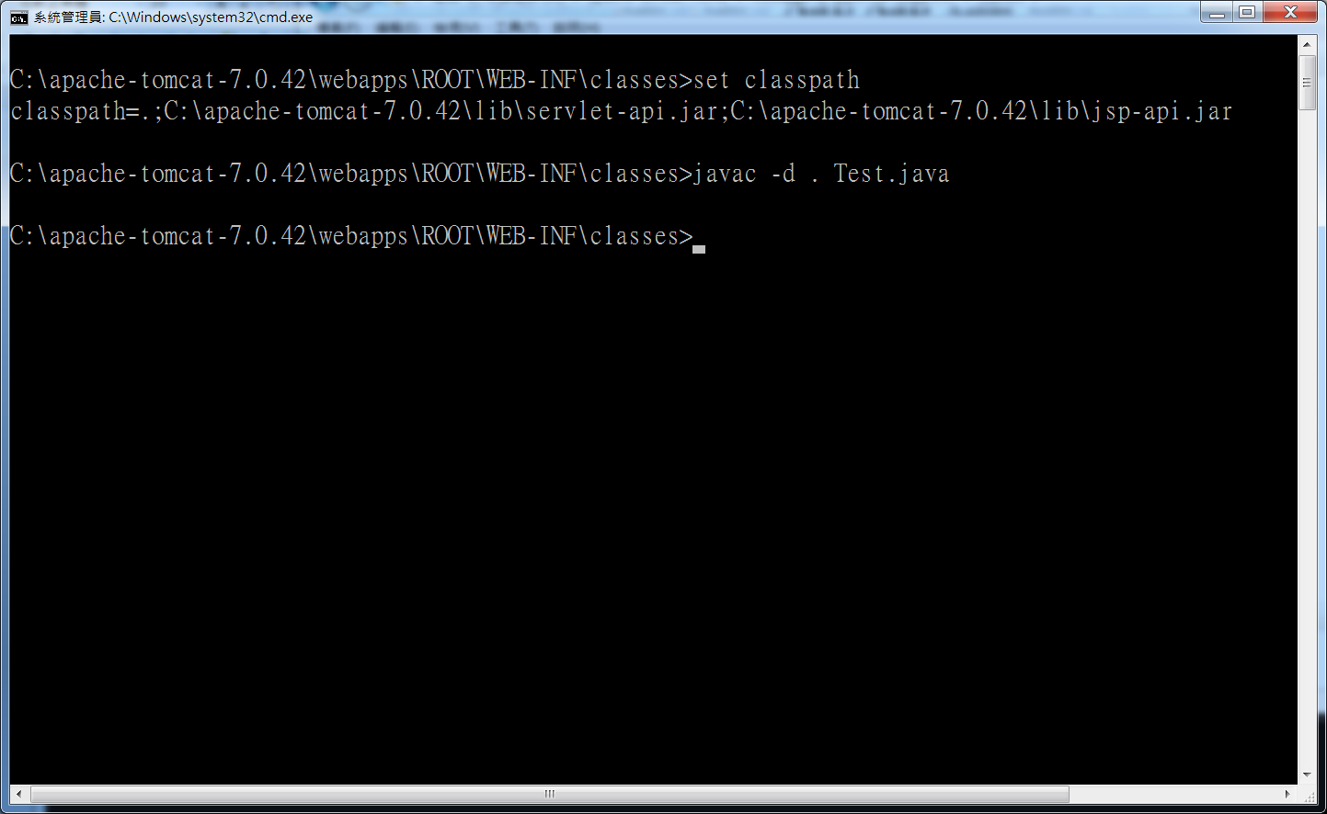
2. C:\apache-tomcat-7.0.42\webapps\ROOT加入 UseBean.jsp

<%@ page import="beans.Test" %>
<HTML>
<HEAD>
<TITLE>Using a JavaBean</TITLE>
</HEAD>
<BODY>
<h1>Using a JavaBean</h1>
<% Test data = new Test(); %>
The message is: <%= data.msg() %>
</BODY>
</HTML>
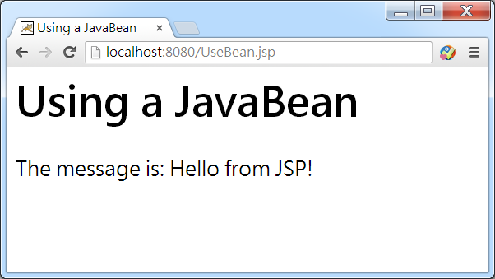

(b)Get/Set Value Using JSP Set Property
1.建立JavaBean類別 C:\apache-tomcat-7.0.42\webapps\ROOT\WEB-INF\classes\Test2.java 並編譯

package beans;
import java.io.Serializable;
public class Test2 implements Serializable
{
public Test2()
{
}
private String message = "Hello from JSP!";
public void setMessage(String message)
{
this.message = message;
}
public String getMessage()
{
return this.message;
}
}
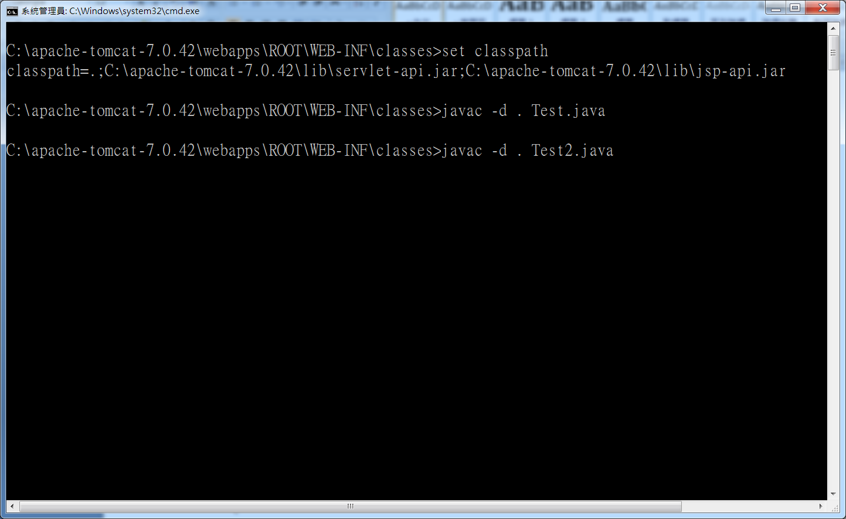

2. C:\apache-tomcat-7.0.42\webapps\ROOT加入 UseBean2.jsp
<HTML>
<HEAD>
<TITLE>Getting a Property Value</TITLE>
</HEAD>
<BODY>
<H1>Getting a Property Value</H1>
<jsp:useBean id="bean1" class="beans.Test2" />
The message is: <jsp:getProperty name="bean1" property="message" />
<br/>
<jsp:setProperty name="bean1" property="message" value="Hello again!" />
Now the message is: <jsp:getProperty name="bean1" property="message" />
</body>
</html>

(C) Web Server Request方法
<HTML>
<HEAD>
<TITLE>Decoding an HTTP Request</TITLE>
</HEAD>
<BODY>
<H1> Request Information </H1>
JSP request method: <%= request.getMethod() %>
<BR>
URL for the request: <%= request.getRequestURI() %>
<BR>
Protocol of the request: <%= request.getProtocol() %>
<BR>
Server name: <%= request.getServerName() %>
<BR>
Path: <%= request.getServletPath() %>
<BR>
Server port: <%= request.getServerPort() %>
<BR>
Remote address: <%= request.getRemoteAddr() %>
<BR>
Remote host: <%= request.getRemoteHost() %>
<BR>
Locale: <%= request.getLocale() %>
<BR>
User agent: <%= request.getHeader("User-Agent") %>
</BODY>
</HTML>

